Fees and Charges, 2025/26 – equalities impact statement

Background
Overall position

  - The budget framework for 2025/26 reflects a baseline assumption that £1.7m of additional income will be generated through an average 5% increase in discretionary fees and charges but with all current concessions and exemptions retained.

1.2 In a small number of cases, an increase of slightly above 5% is proposed. This is usually due to the impacts of roundings, where charges are expressed to the nearest £1 or multiple thereof. In other cases, such as care home fees, charges are set in accordance with full-cost recovery in line with relevant national guidance.

1.3 In contrast, no changes to charges are proposed for (i) wraparound and additional hours in nursery schools and (ii) HRA-related services such as communal heating and heat with rent , the latter due to an on-going detailed review of energy use, costs and tariffs for recharging purposes. Charges for garages likewise remain frozen while the garage estate is surveyed to determine stock condition. Proposed licence fees for Houses in Multiple Occupation (HMOs) have similarly been frozen given the size of the balance on the statutory ringfenced reserve in this area.

1.4 In accordance with the previous decision of the Transport and Environment Committee, officer-recommended increases for parking permit-related charges have been determined with reference to the average inflation rate for the period from January to December 2024 inclusive. Equivalent proposed rates for pay and display parking have been set to complement wider transport policy objectives and are, in the main, between 10% and 12%.

1.5 The revenue budget update report to the meeting of the Finance and Resources Committee on 4 February detailed proposed charges across all of those areas expected to be available as of the time of budget-setting on 20 February, with a consolidated list also circulated to members on 7 February.

1.6 As of the time of preparation, charges in a small number of areas remain to be confirmed, with the main ones being in community access to secondary school sports facilities, where finalisation of the level of increase is subject to parallel charge approval by Edinburgh Leisure given the previously agreed policy of price harmonisation. Confirmation of proposed charges in these areas will be communicated to members as they become available.

Poverty Commission recommendations

1.7 As part of 2023/24’s budget deliberations, members asked that consideration be given to the Poverty Commission’s recommendations in this area. While the Commission did not make any particular calls to action that relate to the fees and charges that are the specific subject of Council’s decision, it did ask the Council and all community planning partners to consider the impact their budget decisions might have on people affected by poverty.

1.8 One potential way of undertaking this assessment is application of the Scottish Parliament Information Centre (SPICe)/Joseph Rowntree Foundation framework which sought to assess the impact of local authorities’ savings plans on services used more by better-off groups of people or poorer groups of people. The framework classified council services into six categories on a scale between "Pro-Rich" and "Very Pro-Poor”, a summary of which is provided below. 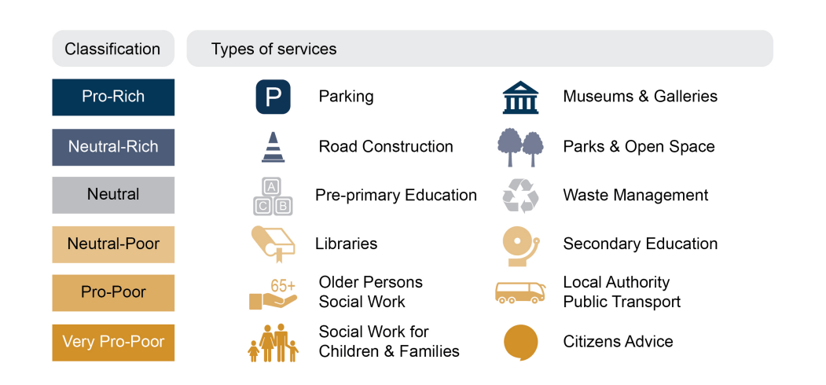
1.9 It is important to emphasise that this framework was developed from the perspective of those using these services at a general level and not specifically in the context of fees and charges being levied, albeit the underlying principles and categorisations may still have some relevance. It is also worth bearing in mind that in a significant number of cases, a framework of concessionary and reduced charges is already in place, with other charges, particularly in the area of health and social care, subject to means testing.
1.10 Given the timescales within which these charges now require to be set for 2025/26, the ability to undertake both detailed socio-demographic analysis of the actual users for each of these services and engagement work to understand likely impacts better is limited, albeit in some cases proposals brought forward have taken implicit consideration of these anticipated impacts. The need to deepen this understanding is acknowledged and will be taken forward as part of the budget process, alongside parallel development of areas such as gender budgeting.
1.11 These points notwithstanding, the following general points are suggested for consideration in respect of 2025/26’s budget:
  - any increases in charges for parking and museums and galleries are likely to have a relatively lower impact on poorer communities. The budget framework assumes increases in on-street car parking charges of between 10% and 12%, with the equivalent increase for parking permits being between 3% and 7%, depending on vehicle type. Links to relevant integrated impact analyses are included later in this briefing;

  - increased charges for licensing, planning and venue hire are likewise expected to have proportionately lower impacts on poorer communities;

  - increases in cultural venue charges would also be anticipated to have lower impacts on poorer communities and there are already relevant discounts in place for charitable/community groups. In addition, as part of the approved budget for 2023/24, a specific recurring £0.100m Cultural Access Fund was established to maximise the reach of community-led access to cultural and creative programmes and facilities for, and with, participants, creative practitioners, families and audiences;

  - an amnesty on overdue library fines was approved as part of the 2023/24, with their removal subsequently made permanent. Library services are typically seen as ‘neutral-poor’ from a poverty impact point of view;

  - although not specifically covered in the SPICe analysis, “funeral poverty” remains an important issue, with available statistics pointing to escalating costs and limited available avenues for financial support. The Scottish Government-established ‘Funeral Payment and Funeral Poverty Reference Group’ in March 2021 raised concerns around rising local authority burial and cremation fees. Following a freeze in charges for 2023/24 and a 5% increase in 2024/25, officers are again recommending a 5% level of increase in 2025/26 in line with the Council’s wider policy for the coming year, albeit with simpler arrangements (with lower associated charges) retained; and

  - the framework does not have huge relevance to the chargeable services provided by the Education and Children’s Services Directorate. Community letting and adult education classes are, however, relevant, with two concessionary rates already in place.

1.12 As noted in the preceding section, a range of concessionary arrangements is currently in place as summarised in Appendix 1.
Council Tax
1.13 The officer-recommended budget proposes an 8% increase in Council Tax levels.
1.14 A detailed Integrated Impact Assessment (IIA) in this area has been undertaken and may be accessed here. This assessment highlights a range of mitigations in place for eligible households, including active promotion of the Council Tax Reduction Scheme (CTRS).
Fees and charges
1.15 While most of the Council’s fees and charges are not subject to an equivalent system of assistance, services do take account of the ability to pay in applying these increases. In some areas, such as room and facilities hires, overall income targets have largely been met in recent years through applying proportionately higher increases to commercial clients seen as being better able to meet these costs.
1.16 The Council’s charging policy is also influenced by developments at national level, particularly in the case of education services. Recent Scottish Government initiatives have seen the expansion of free school meals within primary schools, removal of charges for music tuition and also for some curricular activities. The Council has furthermore played a lead role in the expansion of Scottish Child Payments.
1.17 As noted earlier in this briefing, it is proposed that charges for pay and display parking and parking permits be increased by between 10% and 12% and 3% and 7% respectively. As part of developing the Parking Action Plan, six Integrated Impact Assessments were undertaken, including those on pricing strategies, residents’ parking permits and controlled parking zones. These assessments included a comprehensive overview of relevant environmental, equality-related and environmental considerations and an updated IIA has been produced as part of this year’s budget process.
Income generated by changes in fees and charges rates
1.18 The table below provides a broad indication of the current level of income raised by a range of fees and charges. Officers will, however, be able to provide further details on the associated changes in overall income levels for a range of scenarios, taking into account the effects on demand.
Service Area | £m
Community Access to Schools | 2.4
Outdoor Centres | 2.2
School Meals | 1.8
Usher Hall and Assembly Rooms Rentals | 1.6
Culture - Various | 1.2
Tables and chairs permits | 0.6
Port Facilities - Cruise Liners | 0.5
Housing - Stair cleaning | 0.4
TTROs | 0.4
Registrars - Discretionary Charges | 0.4
Adult Education | 0.3

1.19 The additional income raised by changes in parking charges is affected by consequent changes in demand, consistent with the policy intent. It is estimated by officers that each 1% change in charge would increase, or decrease, overall income by £0.120m. The officer assumption is for a 10% increase. This level of income change applies to increases between 10% and 15%.
1.20 It is officers’ assessment that an increase of 20% would see a consequent reduction in demand, such that the overall level of income generated would only be £0.2m higher than in the case of a 15% increase.
1.21 Parking permits currently raise around £7m per year.
Existing concession arrangements for fees and charges Appendix 1
Adult Education | 50% and 80% concessions are available within the existing service charging structure.
Outdoor Education | The Council and the Scottish Child Poverty Action Group regard curriculum residential visits as a “‘cost of the school day”. Left unaddressed, the cost of a residential excursion can be a significant barrier to the participation of pupils from low-income families. A range of strategies is therefore used by schools to maximise attendance. These include Pupil Equity Funding (PEF), out-of-community fundraising, Parent Council contributions, third party grant applications, extended payment plans for parental/carer contributions, and clothing banks. Average attendance in Autumn 2022 was 90%, with 65% of these pupils attending paying the full fee and 35% of pupils attending receiving support through the above strategies. Linked to the ‘cost of living crisis’, schools are reporting significant and growing concerns about maintaining high attendance and meeting residential costs across the school community, not just families on low incomes. External funders are reporting significant increases in grant applications alongside an unsustainable depletion of reserves.  PEF guidance is designed to close the poverty-related attainment gap. It expects all spends to be linked to priority criteria, including ‘reducing the cost of the school day’ and the ‘cost of wider achievement opportunities’. This enables schools to allocate PEF to residential offsite visits.
Burial and Cremation Charges | Local councils do not charge a burial or cremation fee where a child (under 18) has died. After charges were frozen in 2023/24, the proposals to be considered by Council on 20 February reflect an average increase for 2025/26 of around 5% but with simpler arrangements (with lower associated charges) retained. In addition, Funeral Support Payments are also available where the individual accepting responsibility for funeral costs is in receipt of certain benefits.
School Meals | Universal Free School Meal provision is in place for P1-P5, with this provision extended to P6 and P7 pupils whose families are in receipt of the Scottish Child Payment. Eligibility for Free School Meals in secondary schools is linked to receipt of certain benefits. The Scottish Government has also confirmed its intention to extend free school meal eligibility in S1-S3 in eight local authority areas for pupils in receipt of Scottish Child Payment.
Cultural Venues | Various discounts for amateur groups and charities are in place e.g. c.50% reduction at Church Hill Theatre; 20% reduction at Assembly Rooms for UK-registered charities; various reductions at Ross Theatre for charity / amateur events; discretionary 30% reduction in rates at Usher Hall can be offered to key partners (RSNO and SCO), charitable and amateur organisations.
Civic Licensing | Public Entertainment licences - various discounts / reductions are applied for community / charitable / religious / political groups.
Garden Aid | The Garden Aid scheme is available for: Council tenants over 60 years of age and in receipt of housing benefit; Council tenants, private tenants and homeowners that have a disability and are in receipt of either the Personal Independence Payment (mobility) or the Disability Living Allowance (mobility component); Private tenants and homeowners over 80 years of age. An annual administration fee is charged to all private tenants and homeowners which is dependent on their grass area and hedge size If an application has been certified by a Medical Professional (a GP or a Health Worker), the VAT cost will be removed.
Libraries | Various concessions and reductions are applied to libraries charges. For example a 50% concession is available on audio and DVD loans (with no charge for under 16s) with room hire reductions of c. 65% for community groups.
Allotment Rentals | Elderly, student and unemployment residents are entitled to a discount of c.50% on allotment rentals.

unless in the case of pre-approved charging policies, the effect of which would be to require a different level of increase, or for some commercial charges.

