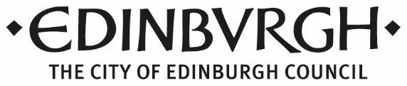
Edinburgh Licensing Forum
Expression of interest in being a member: community representative
About you
Name:
Address:
Postcode:
Phone No: |  | Email:

Please tell us why you are interested in this role
Please tell us about any relevant experience
Having read the accompanying information pack, please tell us about the skills and qualities you feel you could bring to this role
Please give us an example of where your knowledge and experience has allowed you to give a statutory body your perspective on a particular issue.
Any other information that you feel is relevant to your application

Please provide details of two referees who could support your application for this role
 | Referee 1 | Referee 2
Name
Contact address
Phone number
Email
How does this person know you?

I confirm that the information I have provided is accurate and completed to the best of my ability.
Signature Date
Please return the completed form by 30 June 2022 by email to isla.burton@edinburgh.gov.uk or by post to Isla Burton, Rm 4:19, City Chambers, 253 High Street, Edinburgh EH1 1YJ.

