
Edinburgh Children’s Partnership

Annual Report 2024 – 2025

Contents

Introduction 2
Performance Indicators 3
Sub-Group Progress 4
Complex Maternity and Early Years Social Factors /Neurodevelopment pathways 4
Corporate Parenting and The Promise 5
GIRFEC 6
Healthy Places 7
Joint Commissioning 8
Poverty 9
Single Point of Access and Community Mental Health 11
UNCRC 16
Whole Family Wellbeing 17
Youth Work 18
Joint Strategic Needs Assessment 19
Next Steps 21

Introduction

This report represents the second annual review of progress made under the Edinburgh Children’s Partnership Children’s Services Plan 2023–2026.
The Edinburgh Children’s Partnership (the Partnership) is responsible for the strategic planning, development, and delivery of services for children and young people on behalf of the Edinburgh Partnership. Membership includes representatives from the public sector and the voluntary and community sectors, reflecting our shared commitment to collaboration and collective responsibility for improving outcomes for children, young people, and families across the city. The Partnership is currently chaired by the Director of Strategic Planning, NHS Lothian, and vice-chaired by the Chief Social Work Officer and Service Director for Performance, Quality and Improvement (Children’s and Criminal Justice Services), City of Edinburgh Council.
Over the past year, the Partnership’s multi-agency sub-groups have built on the foundations set out in the first year of the Children’s Services Plan and continued to make progress against our shared priorities, working together to ensure that every child and young person in Edinburgh can enjoy their childhood and achieve their potential. Our work remains focused on prevention and early intervention, strengthening joint approaches across services and aligning resources to provide coordinated, timely, and effective support for families, and on addressing inequalities that affect children’s health, wellbeing, and life chances.
This report provides an overview of progress during Year 2 and outlines the planned actions and priorities for Year 3, reflecting our continued commitment to working together to achieve better outcomes for all children, young people, and families in Edinburgh.

Performance Indicators
The Partnership has agreed on 10 high-level performance indicators to measure progress and impact across key priorities in the Children’s Services Plan 2023–2026. These indicators provide a clear and consistent framework for tracking outcomes for children, young people, and families in Edinburgh.
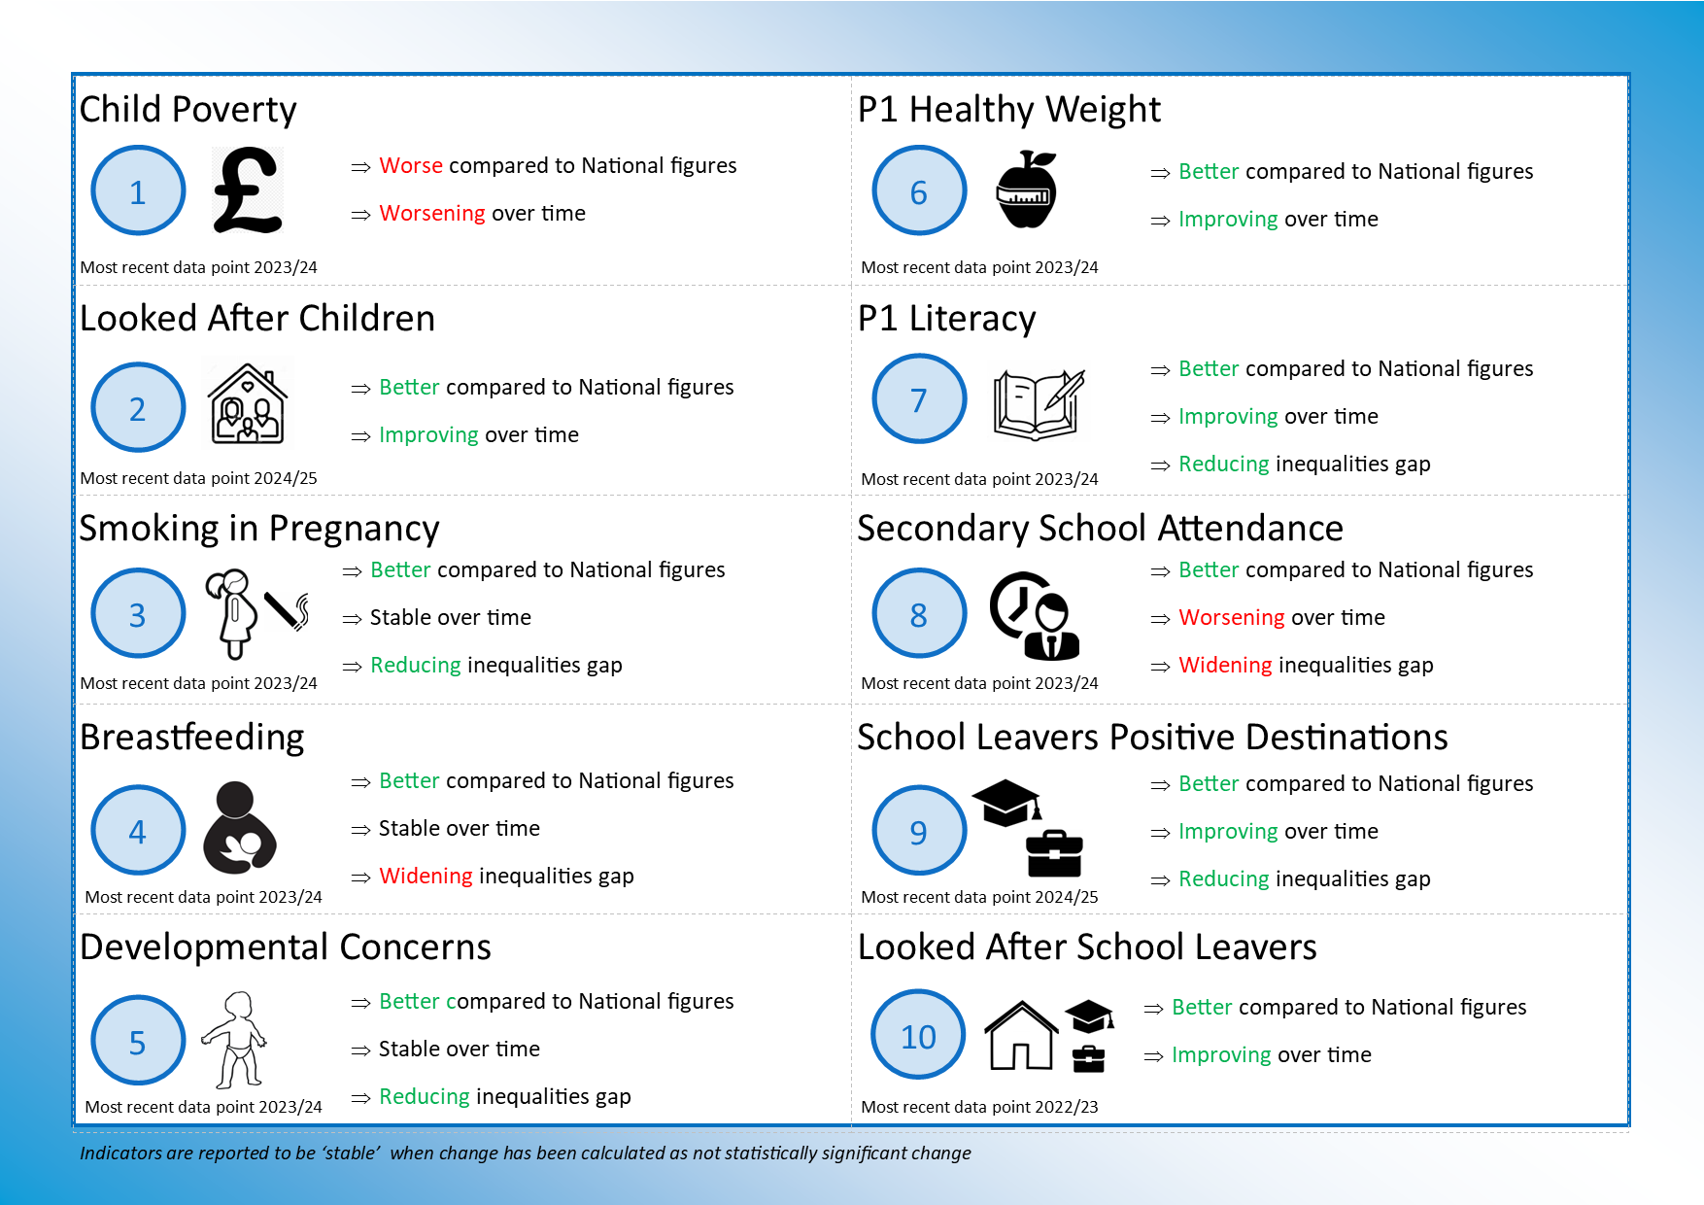

Sub-Group Progress

Complex Maternity and Early Years Social Factors /Neurodevelopment pathways
In a year marked by collaboration, innovation, and a shared commitment to Edinburgh’s youngest citizens, the Maternal and Early Years Working Group, partnering with The Family Hub through the Whole Family Wellbeing Fund, delivered a series of transformative initiatives aimed at improving outcomes for children from pre-birth to age five who face social and complex challenges.
Building Bridges Across Communities
We hosted four vibrant locality events across the city, bringing together over 40 third-sector organisations. These gatherings served as a powerful showcase of community-based support, enabling midwives, health visitors, and frontline practitioners to forge stronger connections with local services. The result? A more responsive, accessible pathway for families navigating early childhood challenges.

Mapping the Gaps
Through a multi-agency mapping exercise, we identified critical service gaps and opportunities for improvement. The resulting report spotlighted ten key areas requiring urgent attention:
This report has been integrated into the Joint Strategic Needs Assessment and is now informing targeted actions across Edinburgh Children’s Partnership (ECP) working groups.
Next Steps:
As we enter the final year of the ECSP plan, our focus sharpens on three strategic priorities:
- Antenatal Referral Pathway: Strengthening early identification and support for families during pregnancy.
- Immigration-Informed Resources: Equipping frontline staff with tools to support families facing precarious immigration status.
- Father-Inclusive Practice: Developing best-practice principles to ensure fathers are actively engaged from the start of a child’s life.
We will also launch a multi-agency consultation to shape the 2026–29 ECSP, ensuring the voices and needs of children pre-birth to five are at the heart of future planning.

Corporate Parenting and The Promise
The City of Edinburgh Council took the publication of plan 24-30 as an opportunity to align the work of the Corporate Parenting Team with their oversight and tracking of the Promise across the city. This is done with the acknowledgement that there are many areas of overlap. In Edinburgh we have worked to establish a Promise Learning Network and over the next year we will work across Edinburgh to scope the work that has been and is being undertaken to keep the Promise by 2030. This will allow for integrated Promise and Corporate Parenting Planning across Edinburgh from 2026. The Corporate Parenting Plan continues to be reviewed six monthly, and copies of the report can be found on the webpage.
Edinburgh’s promise learning network has been established. This brings together people across the Partnership to ensure that the Care Experienced Community have access to appropriate resources and support as and when they need them
Further development of the Corporate Parenting Hub is essential to the delivery of the Update Corporate Parenting and Promise Plan. Work commenced on the final stage of the building improvements in Spring 2025, with completion estimated for Autumn 2025.

Next Steps:
- Soft opening of fully finished hub in October 2025
- Mapping of support through the Promise Learning Network
- Complete and evaluate youth led grant programme
- Fulfil Corporate Parenting plan and development of the joint Corporate Parenting / Promise plan 2026 – 2030

GIRFEC
The GIRFEC working group are progressing action to refresh the partnership approach to GIRFEC. The National GIRFEC principles and National Practice Model are not new to us in the City of Edinburgh. There have been changes and updates over time, but the general principles and values have remained consistent. In recent years practice in the City of Edinburgh has become less consistent and this has been identified through a recent self-evaluation which has identified key areas of improvement required. To refresh and reset practice, updated multiagency GIRFEC guidance and Child Planning Documents have been developed to promote the consistency of the roles of the Lead Professional and Named Person and to further develop the use of the national practice model. This guidance will be launched in late 2025 and will be supported by a learning and development strategy and signposting to new resources and materials including in-person workshops.

Next Steps:
- Identification of a Learning and Development lead officer and develop a learning and development strategy and learning calendar
- GIRFEC learning materials will be added to the core essential learning for Council staff
- Produce a suite of professional learning resources across the partnership to support practitioners to fully embed GIRFEC principles in practice including specific resources to further develop the use of the national practice model
- Develop communication and engagement strategy and associated materials to raise awareness of GIRFEC and support consistent engagement with children and families
- Enhance governance and oversight arrangements to ensure consistent and regular oversight of GIRFEC improvement actions

Healthy Places
The ‘Children’s Services Plan’ includes, among its priorities, a commitment to ensuring that children and young people have access to healthy environments, in line with the UNCRC, to support their health, wellbeing, and ability to fulfil their potential.

Building on the success of the Craigmillar Pilot Project (Year 1), funding was secured to deliver a second phase of activity, once again, in collaboration with local young people.
This phase focused on two key priorities identified during the initial project: improving and creating more hangout spaces for young people and increasing the presence of art and murals within the community.
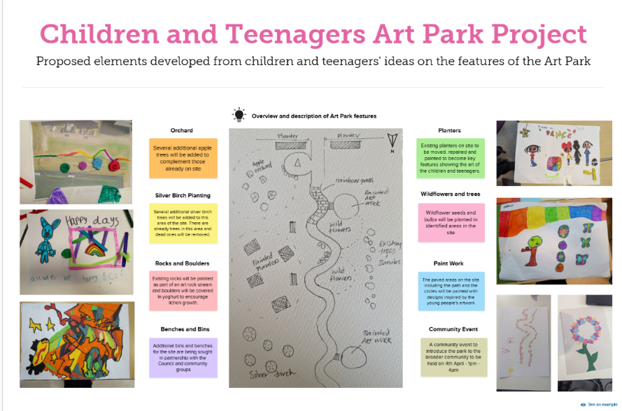
A detailed project plan has been developed to reclaim a vacant area of land and transform it into a vibrant, inclusive ‘Art Park’, designed to promote ownership, belonging, and wellbeing.

The Healthy Places group has also served as a hub for networking, discussion, consultation, and inter-agency collaboration, connecting stakeholders across various initiatives, including The Edinburgh Play Sufficiency Assessment, the Huntershall/Jack Kane redevelopment and the inclusion of children and young people’s voices in the City Plan 2040

Next Steps:
- Year 3 will see the completion and public celebration of the Art Park project. This will provide a platform to revisit priorities identified in the Children and Young People’s Neighbourhood Plan from phase one of the pilot, engaging stakeholders to explore opportunities to further develop priorities identified in the plan.
- A comprehensive resource will be created to build on insights captured in the systems evaluation from the first phase. This will be shared with relevant stakeholders to inform future initiatives.
- The group will continue to facilitate networking and information exchange among stakeholder partners.
- Group membership will be expanded to include additional stakeholders who can meaningfully contribute to promoting healthy environments for children and young people across Edinburgh.

Joint Commissioning
In 2024-25 the Joint Commissioning Group (in conjunction with the working / steering groups for each programme) continued to oversee the allocation / administration of funding in relation to the following three programmes of work.

Connected Communities Programme:
Grant allocation for this 3-year (2024-27) programme began and a Lessons Learned Report was published, outlining the changes made in response to the previous grants programme, as well as early learning from the commissioning of the new programme.

Community Mental Health Grants Programme:
Whilst awaiting Scottish Government confirmation of continued funding beyond March 2025, future commissioning models were explored. This enabled a contract variation, informed by programme evaluation, to be implemented for the year 2025-26.

Whole Family Wellbeing Programme:
Funding was allocated to the 6 successful WFWF collaboratives, and options explored for the allocation of the (smaller) second tranche of funding. This resulted in agreement to fund a seconded position from a third sector organisation into CEC as well as the development of a digital data platform to support effective delivery, monitoring and evaluation of the fund (in response to findings from the Integrated Impact Assessment that was conducted on the impact of original fund allocations).

Ongoing work and Next Steps:

In the first six months of the 2025-26 financial year, the Joint Commissioning group has continued to support the ongoing allocation of funding in relation to these programmes.

Learning from the first year of the Connected Communities Programme has been published. This includes (largely positive) reflections from grant recipients on their experience of the revised approach taken to grant allocation and monitoring in the current 3-year programme. Work will soon begin to consider opportunities for the programme beyond April 2027.

Work is ongoing to support the monitoring and evaluation of the Whole Family Wellbeing Programme, to ensure that learning from this transformation fund can inform future programmes of work in the city.

The Joint Commissioning Group are also engaged in the wider Edinburgh Community Planning Partnership Third Sector Review Process. We will continue to share learning with the Edinburgh Partnership in relation to processes adopted by the Joint Commissioning Group to improve efficiency, grant recipient experience and community impact as a result of allocation of Partnership funds to third sector organisations.

Poverty
We will reduce the number of families and children living in relative poverty by implementing and delivering on the actions set out in the Local Poverty Action Plan
Action 1- Rights Based Poverty Lens and Capacity Building
During 2024 to 2025 the child poverty subgroup was able to develop cross-cutting pieces of work with the maternal and early years complex needs and youth work subgroup to progress child poverty actions.
The group continued to facilitate the uptake of the Edinburgh Money Counts training and access to national child poverty training resources. Focus on supporting NHS Lothian staff highlighted the difficulties clinical staff face in accessing child poverty training due clinical pressures but also in navigating the wide array of local and national training offers. This reflects a Scotland wide picture of low uptake of child poverty training by NHS staff.
Data collection on child poverty priority family types is now incorporated into commissioning of children’s partnership funding streams to ensure focus on those children and families most at risk on poverty and to inform future service designs. Integrated impact assessments are conducted where required.
As part of the Scottish Government funded Cash First Project, we focused on the development of an infant food insecurity pathway for the city. Progress includes engagement with key stakeholders, the completion of a survey to assess need and current support provision and the completion and dissemination of an interim report on findings.
The planned work on a wider holistic cash first financial inclusion offer via midwifery was no longer pursued as further engagement with Social Security Scotland highlighted their own work to increase the uptake of Best Start benefits.
Action 2 - Develop and enhance a data-driven approach to child poverty action planning
Over the past year there has been increasing focus and availability of data relating to child poverty supported by the NHS Lothian public health intelligence team, Improvement Service and Public Health Scotland. As a result of the inclusion of child poverty priority family types, data collection in the Connected Communities funding specs, year one data on the proportion of those families accessing these services is now available. The complexity of local and national data and the lack of a readily available single source of data relating to child poverty combined with a lack of consensus on local child poverty indicators across the community planning partnership have proven challenging to progress this work further.
Action 3 - Welfare rights advice pathways for midwifery, health visiting and family nurse partnership
We established a city-wide, dedicated welfare rights advice support service for the Edinburgh family nurse partnership teams, provided by CHAI and based on learning and experiences from their partnership with health visiting teams. The uncertain local and national funding situations for 3rd sector welfare rights advice support services are the key risks to the sustainability of these services. Furthermore, pressures on frontline clinical staff posed challenges for midwifery colleagues to engage and progress the development of the automated referral pathway work.
Next Steps
Action 1 - Rights Based Poverty Lens and Capacity Building
We will continue to develop and build on partnership work with the maternal and early years complex needs and youth work subgroups.
There are challenges in the coming year over the continuation of the local Money Counts training rollout due to uncertainty over funding. However, there are opportunities to link with NHS Lothian strategic planning colleagues to include child poverty into a wider training offer for acute staff. Other opportunities to consider topics such as ‘ask and act’, gambling harms and support for migrants as part of the local training offer will also be explored.
Work for the coming year on the Scottish Government funded Cash First Project is planned to identify and communicate to stakeholders a sustainable route within existing provisions for families in crisis to access infant formula and wider holistic support. As part of this work there is recognition that the lack of dedicated funding and general uncertainty over funding for 3rd sector support organisations provide challenges and will affect data collection on need.
Action 2 - Develop and enhance a data-driven approach to child poverty action planning
Opportunities for the coming year include work and agreement with partners on a set of local child poverty indicators as part of the LCPAR for 2025 and utilisation of the Public Health Scotland child poverty dashboard for planning and evaluation purposes once it becomes available.
Action 3 - Welfare rights advice pathways for midwifery, health visiting and family nurse partnership
The focus for next year will be to establish a holistic early years welfare rights advice pathway for midwifery, health visiting and family nurse partnership with connections to infant food insecurity support in order to ensure a ‘no wrong door’ approach and easy transitioning between services. This will also be linked to the wider 3rd sector welfare rights advice commissioning work across the partnership.

Single Point of Access and Community Mental Health
Single Point of Access
During 2024 to 2025 the Single Point of Access (SPA) was successfully rolled out from Northwest Edinburgh to the remaining three localities. This included successful integration with Whole Family Wellbeing (WFW). The WFW team have been integral to the successful development of the SPA through the provision of business support and the role of WFW locality co-ordinators liaising direct with families and requesters.
The SPA has successfully established a wide membership including strong representation from third sector, the City of Edinburgh Council and NHS. The SPA has successfully been integrated as part of our Getting it Right for Every Child framework (GIRFEC).
During this phase of development there has been a focus on sustainability, proportionate information sharing, relational approaches and capacity building. This resulted in further developing the role of weekly Immediate Response Meetings (IRM). The IRM is now able to action most support requests, this has resulted in reduced numbers requiring full SPA discussion. This change has improved proportionate information sharing and has reduced workload for SPA members. This has also resulted in the recent decision to move to monthly SPAs with the full membership which will now focus on the sharing of monthly locality request data and locality and service developments.
The ongoing development of the locality co-ordinators providing direct links to both requesters and families has ensured both a relational approach and local capacity building.
The Request for Assistance (RfA) form is now operational citywide. The RfA can be used for requests to the SPA and /or CAMHS through one form. This reduces bureaucracy for those supporting the requests. All requests currently come from the named person or lead professional as part of the GIRFEC process. Almost all requests have evidenced prior GIRFEC planning. Feedback from NHS indicates increased confidence in schools making requests to CAMHS through this process.
During the 2024 to 2025 there was a total of 277 requests to the Single Point of Access, most responses were successfully actioned through the initial IRM discussion through contact with the locality co-ordinator.
Community Mental Health
At the start of 2024-2025 Edinburgh’s Wellbeing Webpages were successfully launched including the dissemination of signposting resources that are now visible in a wide range of our community settings. This has successfully pulled together resources and signposting for parents, children and young people. Between the launch in August 2024 and June 2025 there were 10,606 unique visitors and a total of 22 921 views. The average monthly views were 201. Digital wellbeing supports continue to be an area for further development as part of our overall community mental health strategy.
During 2024-25 the working group conducted a review of the Children's Partnership Community Mental Health strategy. A first phase of recommendations were presented and agreed in October 2024 with final recommendations to be presented to the partnership in October 2025. Contract variations were agreed from March 25 to March 26 to allow the group the necessary time for the process of review and recommendations to the Children’s Partnership.
In coming to the recommendations, to be presented at the Children’s Partnership in October 2025, the review has considered national and local evaluation data, including an independently commissioned evaluation, conducted stakeholder and third sector survey’s and carried out focus groups with primary and secondary aged children.
Next Steps:
Single Point of Access
- The SPA will continue to make more decisions at weekly IRMs to reduce unnecessary sharing of information and reduce workload.
- This will enable a reduced frequency of SPAs and an increased focus on locality data and information sharing. To support this the WFWF business support team will establish a system of tracking monthly data from IRMs that will be shared at the monthly SPAs.
- There will be a slimmed down infrastructure from 4 to 2 locality co-ordinators and with the reduction of the Project Officer within NHS 3 to 2 chairs. This will support the ongoing consideration of a long- term sustainable model.
- This will include consideration of how the SPA links with the wider inclusion and family support infrastructure including WFWF supports, the Education Wellbeing Service and their line management under the Service Manager for Mental Health and Wellbeing.
- WFWF business support will further support the implementation be establishing a sustainable and efficient model to seek regular stakeholder feedback.
Community Mental Health
- The recommendations of the implementation group will be presented to the Children’s Partnership in October 25 seeking agreement to progress.
Communication and engagement with key stakeholders to progress the proposed model for services and supports to fulfil the Scottish Government Framework requirements.
Trauma Informed Practice
The National Trauma Transformation Programme (NTTP) supports the Scottish Government ambition to create trauma-informed and responsive organisations in Scotland.
A Trauma informed and responsive approach (TIRA) is more than training, the approach needs to be embedded across all services, policies and systems, creating trauma informed environments. Implementing this throughout partnership working is a key when creating a culture shift.
The Edinburgh Children’s Partnership multi-agency Trauma Subgroup aims to:
- Raise awareness
- Act as a single point of contact
- Support organisational transformational culture and practice change
- Promote cross-sector collaboration and intersectionality
- Share existing models of good practice
- Identify gaps to inform priorities
In 2024/ 2025 the subgroup has supported actions across the following categories-
Leadership/ Culture
Leaders from across sectors have been encouraged to attend the half day Scottish Trauma Informed Leaders Training (STILT) sessions provided by NHS Education Scotland.
In August 2024 the City of Edinburgh Council (CEC) Corporate Leadership Team approved a request from the Trauma Champion to become a ‘Trauma Informed Organisation’. Making a commitment to embody the key principles of Safety, Trust, Choice, Collaboration and Empowerment within leadership practice and continuous improvement as outlined in A Roadmap for Creating Trauma-Informed and Responsive Change: Guidance for Organisations, Systems and Workforces in Scotland (2023) There was a recognition that leaders at all levels have a key role to play in setting the culture, priorities, values and behaviours of an organisation aligned with those of a trauma-informed and responsive approach.
Progress on further strategic developments in this area has been hampered by a long-term absence of the Trauma Lead and the HSCP Trauma Champion leaving post.
Staff Wellbeing
Practitioner wellbeing is a key priority during in person trauma training sessions with links to supports and resources provided.
A self-evaluation informed action plan has been developed with the CEC Organisational team Trauma and Wellbeing lead. Helping shape what psychological safety might look like in the workplace and developing a list of available trauma support organisations. Resources supporting staff wellbeing are available on the CEC My Learning Hub and shared with partner agencies.
Staff Knowledge and Skills
The NTTP training framework divides roles in the workforce into four main training levels. Trauma Informed, Trauma Skilled, Trauma Enhanced and Trauma Specialist. Each level outlines the expected knowledge, skills and behaviours workers are expected to develop in relation to their practice.
There is an increased awareness of the access to online Level 1 Trauma Informed and Level 2 Trauma Skilled training which can be accessed on TURAS.
Level 2 Trauma Skilled Transforming Connections has been delivered in person by the Trauma Lead to over 371 staff from across CEC teams since 2023.
97.7% indicated they feel confident to use the information learned to reduce triggers for people they are working with that may be impacted by trauma
All Whole Family Wellbeing funded organisations have access to Level 2 Trauma Skilled Transforming Connections training provided by the WFW central team.
Addressing the gap identified- WFW funds have been used to recruit a Trauma Coordinator to specifically offer support, Level 2 Trauma Skilled training, advanced modules and reflective practice sessions to children and families’ practitioners in the voluntary sector.
A new professional learning strategy for education staff has been developed and will be implemented by the CEC Educational Psychology Service. Edinburgh learns with nurture: regulate, relate, educate blends nurture with the fundamentals of trauma informed practice and the neuro-sequential model. The CEC nurturing approach recognises that positive relationships are central to both learning and wellbeing.
28 staff have completed Training 4 Trainers for Trauma Skilled level 2. As facilitators are required to be supported by an Enhanced practitioner, the absence of a Trauma Lead and staff capacity has presented challenges in coordinating and developing continuity of in person training for CEC staff.
Access to Enhanced Level 3 Trauma training continues to be a challenge. Community Mental Health Funds have supported an Enhanced Trauma training pilot for a cohort of practitioners from WFW funded organisations. The training programme has been developed and delivered, monthly coaching sessions are being provided and reflective leadership sessions are being developed to help embed the approach. Additional WFW funding has been secured to fund a part time Clinical Psychologist to expand the pilot. NHS recruitment processes have delayed progress. Any models will aim to complement the work being developed in NTTP Trauma Responsive Social Work Services.
Enhance Practice
The Trauma Ambassadors: Passionate About Trauma Network is well established with approx. 140 trauma ambassadors from across CEC, HSCP, and the 3rd sector. Bimonthly sessions offer peer support and a space to share resources, knowledge and good practice.
Residential services have reviewed and been trialling a new risk assessment process using a trauma informed and responsive lens. Focusing on a strength-based approach, shifting from risk to safety- the new “Safe and Sound plan” uses the window of tolerance, recording what matters most to each young person. There is a strong focus on relationships, ensuring a consistent understanding on what creates safety for each young person and supports them to regulate emotions.
Participation/ Lived Experience: Trauma Informed Parenting Support
With the support of the WFW Trauma Coordinator, a group of parents with lived experience of trauma are involved in steering the codesign, pilot and evaluation of trauma support for parents and carers. Sessions and courses delivered with the support of partner organisations, aim to help support parents to understand their own experiences of trauma and learn effective coping strategies to help support their own and their child’s emotional responses.
Next steps:
Leadership/ Culture
The CEC Trauma Lead post contract ended in September 2025. Funding is to be redirected to prevention-based work incorporating a trauma informed approach. With the absence of a HSCP Trauma Champion and a CEC Trauma Lead, consideration will need to be given as to how strategic planning will continue to facilitate TIRA transformation across the partnership.
Tools within A Roadmap for Creating Trauma-Informed and Responsive Change: Guidance for Organisations, Systems and Workforces in Scotland (2023) could be utilised to support strategic leaders to identify gaps and inform long term priorities and plans.
A local evaluation and impact measurement plan could be developed with the support of Improvement Service (IS) to support the mapping of progress and understand the impact of the work happening across Edinburgh to embed trauma informed services, systems and workforces.
Staff Wellbeing
The development of Leadership Trauma Lens sessions, Trauma Informed Support and Supervision Models and Trauma awareness sessions on Secondary/ Vicarious trauma will be supported by The Whole Family Wellbeing Team.
Staff Skills and Knowledge
Consideration will need to be given to the feasibility of Multiagency Trauma Skilled Level 2 in person training programme in the absence of a CEC Trauma Lead. Solutions will need to be explored to ensure a sustainable model is implemented which includes coordination, training and support for trainers, a booking system model and follow up reflection sessions.
The NES Trauma Lens Training Guidance can be adapted and developed to support practitioners and training facilitators to take a trauma lens when planning and delivering a range of other training and group work. Level 1 online trauma informed training is to become essential learning for all CEC staff from March 2026. Building on the learning from the initial WFW Enhanced trauma training pilot, the pilot will be extended to expand the model.

UNCRC
United Nations Convention on Rights of a Child (UNCRC) Act came into effect in July 2024, giving children and young people legal redress if their rights are breached. The purpose of the UNCRC - Edinburgh Children’s Partnership (ECP) working group is to provide strategic oversight and drive forward action to deliver on the ECP plan 2023-2026 priority:
‘We will ensure the rights of all children and young people in Edinburgh are upheld by embedding UNCRC into daily practice and processes.’
The group leads on the timely production of the three-yearly Children’s Rights Report in respect of partnership activity. The group has reviewed priorities within the report and identified which of the actions sit with the sub-group to progress. At this stage, the group focus has been on providing a robust framework for self-assessment and progression, and awareness raising of the reporting requirements & training. The group has benefited from exploring the NHS framework, discussions with the Improvement Service and a pan-Lothian group.
Year 2 Actions:
- Review of membership within the group
- Reviewing the Children’s Rights Report plan, prioritising areas of subgroup focus.
- Creating and advertising the reporting mechanism for capturing children’s rights work across the partnership.
- Development of a UNCRC webpage (hosted on the Edinburgh.gov.uk website, can be accessed by children, parents, employees across the partnership and wider) including short training videos.
- The subgroup have been upskilled in the UNCRC Framework
- Wider inputs / connection with the Improvement Service (UNCRC) and pan-Lothian UNCRC group.

Next steps:
- Share the model of UNCRC reporting and self-assessment with ECP
- Early analysis of the children’s rights work in the city, supporting identifying priorities for the next Children’s Services plan
- Develop a partnership participation strategy

Whole Family Wellbeing
The year saw the implementation of funded Whole Family Wellbeing (WFW) collaborations. Six multi-agency collaborations, that are supporting families and changing systems. This involved focused support around monitoring, impact and evaluating of the collaborations. With reporting on implementation, sharing learning from the transformational approaches and supporting this into actions within wider workstreams.
With the Scottish Government announcement of an extension of WFW funding there was significant time dedicated to the best approach to funds, utilising the data and voice analysis. The model of funding for the extension period provides an opportunity to both embed the transformational changes in line with local and national evidence, and to support the principles of sustainability.
Increasing of visibility and adoption of Whole Family Support (WFS) principles has taken place through reflective sessions, upskilling and peer model. A short life working group undertook focused, co-design to creating a guide and a toolkit to support the progression of WFS in Edinburgh. Events such as Engaging Families: Accessing Support have had strong attendance and engagement. A comprehensive ‘pathways’ to support quick guide and in-depth booklet have been published and shared.
The roll-out of evidence-based Trauma Informed models in line with the Trauma Informed Working Group and delivery of a suite of trauma based, holistic family support training and upskilling (through reflective spaces and use of the National Trauma Roadmap and Family Support Self-Assessment) has been delivered. And this continues to grow, see actions for next steps.
Co-production has been a focus, through the participance strand of WFS. Exploring with funded collaborations and partnership members how they can approach co-design and co-production. A Parent panel has come together and have clear examples of meaningful activity.

Next steps:
- Continue to increase visibility and adoption of WFS principles across a wider audience, including Adult services – short, focused sessions being planned for 2026 and Getting it right for families workshops.
- Share the learning from Implementation Reports.
- Confirmation and continued reflective impact monitoring of the fund extension

Youth Work
Year 2 has continued with a focus on community-based youth work in Edinburgh for children and young people, promoting the value of safe spaces with trusted adults. The strength has been a continued multi-agency focus and commitment to this work under the Plan.
During 2024-25, the working group was fully established with a defined work programme aligned to the Plan’s community-based opportunities aim and the eight priorities of Edinburgh’s Youth and Children’s Work Strategy:
- Reducing inequality and the impact of poverty
- Health and wellbeing
- Closing attainment gap
- Rights and participation
- Develop the skills of youth and children’s workforce
- Communicate with a range of stakeholders
- Increase partnership working between youth and children’s services
- Improve equality and diversity within youth and children’s work services
These priorities have provided the framework for thematic learning events designed to engage the wider youth and children’s work sector alongside key partners.
The first thematic event focused on youth work and poverty, with a summary report shared widely among strategic partners. This report also informed a youth and children’s work input to the most recent Local Child Poverty Action Report.
As Year 2 marked the halfway point of Edinburgh’s Youth and Children’s Work Strategy, a sector wide reconnector event was held to review progress and celebrate successes across the 8 priorities. A fuller report is available from the event, as well as a series of ‘calls to action’ which will shape future partnership activity and form the basis of the working group’s Year 3 workplan.
The working group also collaborated with Corporate Parenting and The Promise leads to contribute to themed symposiums, highlighting the role of youth work and community-based services in supporting care-experienced young people and delivering on The Promise.

Next Steps:
The calls to action identified in Year 2 will guide Year 3 activity, structured around the 8 strategic priorities. This will provide continued opportunities to collaborate with multi-agency partners and further demonstrate the contribution of community-based youth and children’s work to the broader Partnership aims.

Joint Strategic Needs Assessment
A Joint Strategic Needs Assessment (JSNA) is critical in informing the planning and commissioning of health and social care services, ensuring that resources are allocated effectively to improve health outcomes and reduce health inequalities. In order to inform the Edinburgh Children’s Services Plan 2026-2029 with a robust evidence base, work began in Year 2 of the current plan (2023-2026) to carry out a JSNA specifically for Edinburgh’s children and young people.

This has now been published and in line with current national and local priorities for a greater focus on prevention and early intervention, the JSNA focusses on identifying opportunities to support children, young people and families to develop and maintain good health and wellbeing. In addition to information on demographics and some key health outcomes for children, young people and families in Edinburgh, the JSNA also reports on the extent to which Edinburgh is supporting children, young people and their families to access the Building Blocks of Health, that are set out in the Health Foundation’s evidence-based framework. The report makes reference to Scottish Government’s Children, Young People and Families Outcomes Framework - core wellbeing indicators; SHANARRI and UNCRC.
The JSNA also takes a further ‘deep dive’ into three specific topic areas, identified following an Edinburgh Children’s Partnership development session:
- Homelessness
- Additional Support Needs
- Universal Access to Healthy Environments and Opportunities i.e. the things that Edinburgh offers to all children and young people in addition to statutory health, education and social care services.
Each of these deep dive sections describe current levels of need as well as an assessment of opportunities for changes that could be made to better meet those needs.

Next Steps
In the final year of the Children’s Services Plan 2023–2026, the Edinburgh Children’s Partnership will strengthen its alignment with the wider work of the Edinburgh Community Planning Partnership and the Edinburgh Partnership Board (EPB) Transformation and Improvement Programme.
A key priority for Year 3 will be the delivery of an induction and development workshop for Edinburgh Children’s Partnership members. This will support a shared understanding of how the Partnership’s activity links to wider EPB outcomes and ensure greater coherence between strategic planning for children’s services and the city’s broader ambitions.
Alongside this, work will continue to strengthen governance and reporting arrangements, providing clearer and more consistent routes for reporting Edinburgh Children’s Partnership outcomes into the EPB. This will enhance oversight, support collective accountability, and ensure that children’s services are fully embedded within the city’s wider community planning framework.
These actions will help ensure that, by the end of the current planning cycle, the Partnership is well positioned to contribute effectively to future strategic priorities and the next phase of integrated planning for children, young people, and families in Edinburgh.

