Planning and Performance Framework

Contents
Contents 1
Introduction 2
National Context and Statutory Duty 3
Edinburgh Council Strategic Context 4
Performance Management - Integrated Planning and Performance 6
Roles and Responsbilities 7
Key Performance Measures 8
Benchmarking 11
Performance monitoring and scrutiny 12

Introduction

The Planning and Performance Framework sets out our approach to planning and performance in the Council. It sits alongside the Council Business Plan: Our Future Council, our Future City 2023 – 2027, and will monitor progress against our three priorities and ten outcomes:
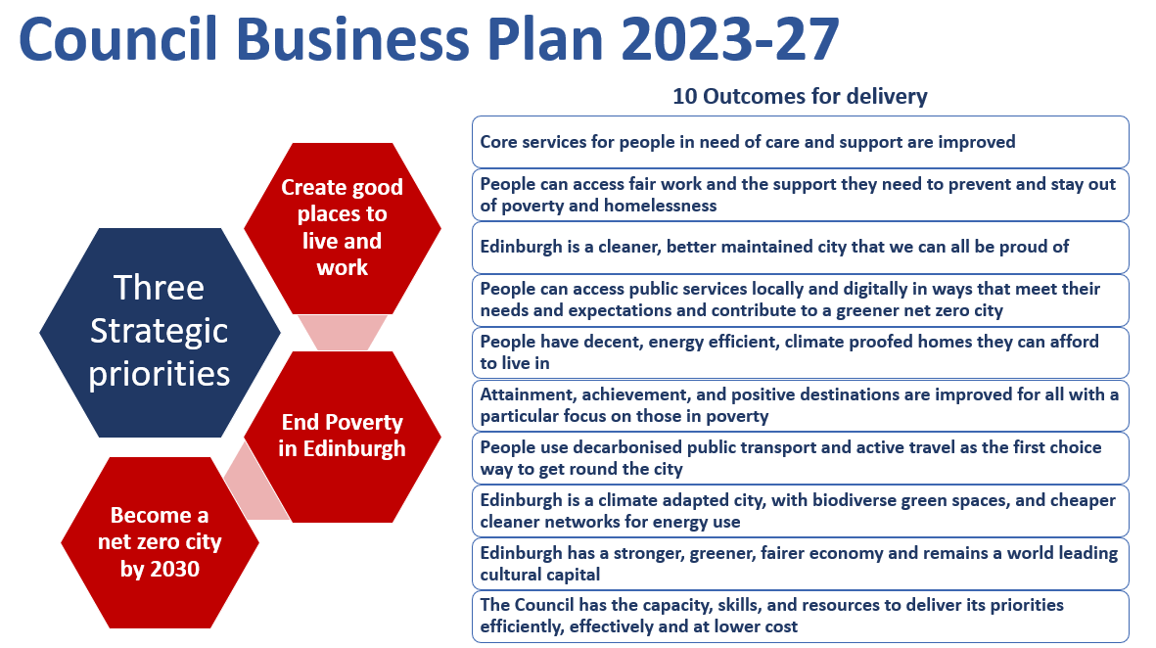
The Council Business Plan is one part of a golden thread linking our priorities to the shared goals of the Edinburgh Partnership and our Community Planning Partners and towards our long-term ambitions for Edinburgh to be a fair, welcoming, pioneering, and thriving city, as expressed by the 2050 Edinburgh City Vision. These priorities represent a core focus for all our teams over the next phase of the city’s development and how we will reform our services.
Through the development of the Planning and Performance Framework (PPF) we aim to:
- work transparently and be held accountable for the delivery of our priorities and outcomes;
- identify areas of underperformance and drive improvements;
- use our performance information including benchmarking data to drive continuous improvement;
- demonstrate best value;
- prioritise service delivery within the resources available; and,
- learn from our past performance in a way which improves our future performance.

National Context and Statutory Duty

This section outlines the wider national context and the statutory duty for Best Value that informs our Performance and Planning Framework.

National Performance framework
The Scottish Government’s National Performance Framework aims to:
- create a more successful country
- give opportunities to all people living in Scotland
- increase the wellbeing of people living in Scotland
- create sustainable and inclusive growth
- reduce inequalities and give equal importance to economic, environmental and social progress
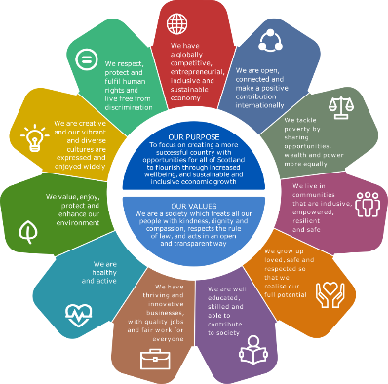
The framework informed the development of our Business Plan and we have mapped our outcomes to the National framework outcomes. See Appendix B -Strategic Outcomes Map.

Best Value
Best Value is a statutory duty as set out in the Local Government (Scotland) Act 2003 and applies to all public bodies in Scotland. It’s purpose is to ensure effective use of resources, good governance and continuous improvement in order to deliver better outcomes for people.
Best Value Audits consider a Council’s compliance with its statutory duty of Best Value. They are carried out by externally appointed auditors on behalf of the Accounts Commission. At least once every five years, a Best Value Assurance Report (BVAR) will be produced on each council.
The Accounts Commission’s Direction 2021 on Public Performance Reporting came into force in December 2021 and defines how local authorities can show that they are achieving Best Value for the people they serve. We will ensure our framework is kept under review and in line with any future changes in guidance.
The Council is externally audited annually, and this assessment considers the effectiveness of the Council’s arrangements to achieve Best Value. This supports the more in-depth review of Best Value carried out by the Accounts Commission.
At the time of writing this framework the City of Edinburgh Council’s most recent Best Value Assurance report was published on 26 November 2020. Recommendations in the report are being actioned and progress regularly monitored through Committee.
The report highlighted areas for improvement in performance management which we seek to address in the design of the Planning & Performance Framework. The report’s recommendations included:
- embedding a process of continuous improvement;
- improving performance reporting by making better use of performance measures and targets, particularly to demonstrate the impact of improvement work; and
- further improving performance reporting by publishing easily accessible, up-to-date performance information on our website.

Edinburgh Council Strategic Context

The Business Plan sits within our wider ecosystem of strategic planning including the 2050 City Vision, Edinburgh Partnership, and links with the Edinburgh Health and Social Partnership.

City Vision 2050
The 2050 Edinburgh City Vision reflects feedback from residents who told us that they want their city to be fair, pioneering, welcoming and thriving – a city that belongs to all of us, and where we all belong. These views have shaped the 2050 City Vision principles which will help to shape and inform our actions now and in future.

Edinburgh Partnership
Through the Edinburgh Partnership we are committed to working with our community planning partners – including community groups and community councils, public, private, and third sector organisations – across the city to deliver the outcomes and goals we all share, and which can only be achieved when we work together.
The Edinburgh Partnership Community Plan 2022- 2028 describes the framework for that joint working and focuses on actions needed to end poverty in Edinburgh.
To do this, partners are committed to working together, seeking opportunities to share assets, services, and resources towards the three common outcomes set out in the Edinburgh Partnership Community Plan:
- Enough money to live on. All partners are committed to working together to deliver a more coordinated approach to income maximisation, support, and advice services. The Plan aims to make sure all residents have access to income maximisation support where and when they need it and receive the same high-quality support wherever they are in the city.
- Access to work, training and learning opportunities. Partners are committed to working together to provide new and additional targeted support to help people into work, training, or learning. This includes planning of intensive integrated family support programmes, support for people on release from prison, support for care experienced young people, and improved support for people from the BAME community.
- A good place to live. The places people live and work, their connections with others and the extent to which they can influence the decisions that affect them, all have a significant impact on their quality of life and wellbeing. Towards this, all partners are committed to working together to create good places to live in Edinburgh and accessible and open places, with good links to health, childcare, and other services.

Business Plan

The Business Plan was approved by Full Council in December subject to amendment following budget approval in February 2023. This includes a detailed delivery plan setting out the specific actions we will deliver, initially in the first two years.
The Business Plan sets out three priorities and ten outcomes for the Council. The three priorities are:
- End poverty in Edinburgh
- Become a net zero city by 2030
- Create good places to live and work.

Edinburgh Health and Social Care Partnership
The Public Bodies (Joint Working) (Scotland) Act 2014, required local authorities and health boards to integrate their health and social care services in a new public body. The Edinburgh Integration Joint Board (EIJB) was established on 1 July 2016. Its membership comprises councillors from the City of Edinburgh Council, members of the board of NHS Lothian, care and clinical leads, third sector representatives, carers, services users and staff representatives.
The services for which the EIJB is responsible are provided by The City of Edinburgh Council and NHS Lothian through the Edinburgh Health and Social Care Partnership (EHSCP). The EHSCP provides services as set out in directions from the IJB to the Council and NHS Lothian as well as the IJB’s strategic plan.
The EIJB is currently developing their new strategic plan, which is scheduled to be published in April 2023, subject to approval, and thereafter will develop a new performance framework. The EIJB Performance and Delivery Committee provides assurance to the EIJB of operational performance of services delivered by the HSCP. The EIJB must publish an Annual Performance Report each year containing not only local performance information but also an assessment of performance against the Core Suite of Integration Indicators and the Ministerial Strategic Group for Health and Community Care Objectives. The 2021-22 Annual Performance Report was published in autumn 2022. The EIJB is responsible for performance monitoring and scrutiny of the HSCP services, however it is recognised the Council continues to have an interest in the services provided by the Council for HSCP.

Key Strategies and Plans
There are other key strategies and plans that exist within our Council which will enable and support the delivery our Business Plan priorities. For example, the People Strategy and the associated Strategic Workforce Plan outlines our vision for our workforce, the necessary changes needed in the coming years and how these will support the delivery of the Business Plan.

Performance Management - Integrated Planning and Performance

Overview
Our Business Plan forms a key part of our strategic Planning and Performance Framework. The Business Plan sits within the wider ecosystem of strategic planning and performance for the Council as shown in the following diagram:
The framework ensures that our priorities, outcomes and actions (key projects/workstreams) are aligned to performance measures which are appropriately monitored and actioned.
To measure the Plan effectively we will:
- measure and monitor the progress we make in delivering the Business Plan actions,
- identify and monitor the KPI’s that show the impact/improvement achieved for each of the outcomes as a result of delivering the actions
- identify and monitor the measures that will demonstrate the overall delivery of our three strategic priorities and the Plan as a whole.

Alongside monitoring delivery of the Business Plan, we also monitor service delivery performance at each level in the organisation through management and operational performance information.
We will further enhance performance monitoring through the development of a Public Performance Scorecard providing a suite of key performance indicators from across Council services that will be monitored internally, scrutinised through Committee and published on our website.
The framework will be underpinned by the “Plan, Do, Check, Act/Review” continuous improvement model and delivered though a robust annual cycle.
The approach embeds a “golden thread” between the Council Business Plan, strategies, annual Directorate/Divisional service plans and colleague annual performance conversations, ensuring a clear understanding of our key deliverables across all our services.

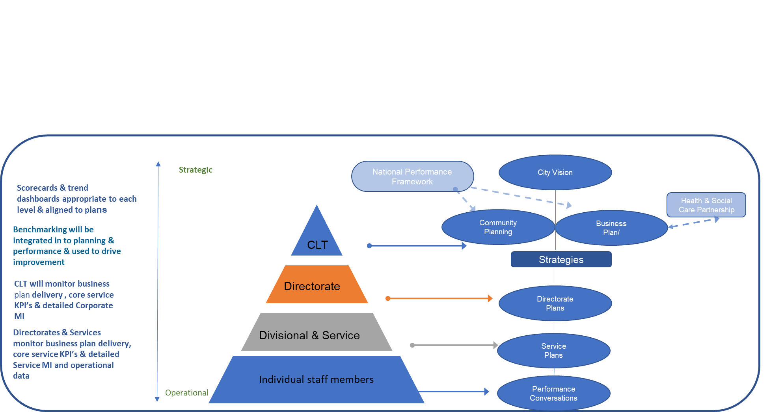

The core components of the Planning and Performance annual cycle are summarised in the illustration below:
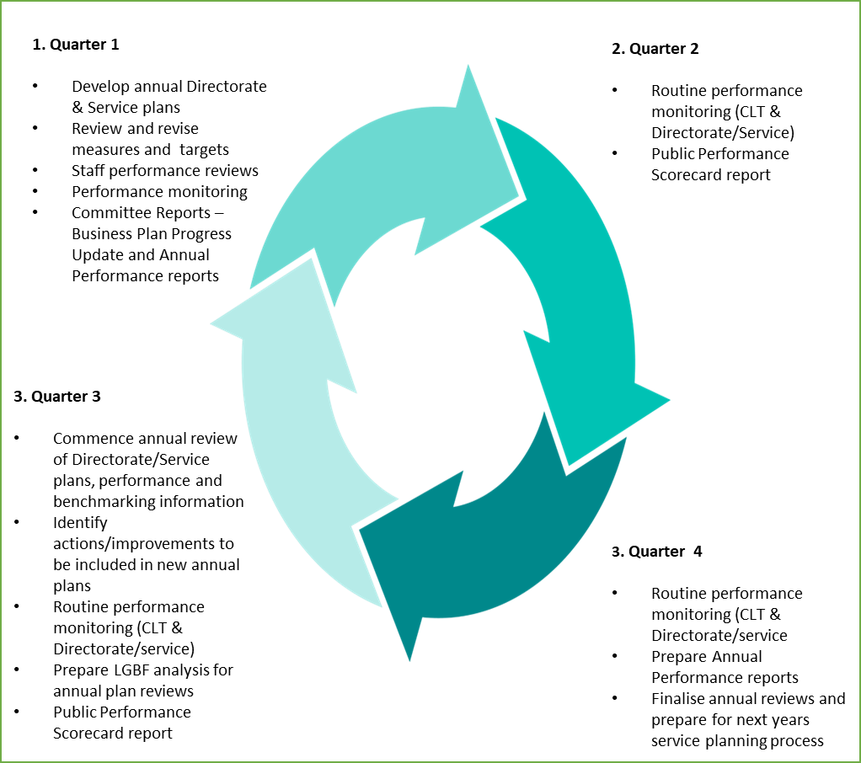
Performance and Planning Annual Cycle
Annual service planning (Q1): The planning stage will commence in the first quarter of the year and will focus on what services expect to deliver over the next 12-month period. It takes into account the output from the review process and annual budget cycle. It This approach will cascade the priorities and outcomes in the Business Plan down through annual service plans to individual workloads. To ensure that the process is simple but meaningful we have a Plan on a Page template and supporting guidance pack.
Annual plan review process (Q 3-4): The review process will commence towards the end of the third Quarter and be finalized in the fourth Quarter. This review will inform our annual performance reports, feed into the annual budget process and the annual service plans for the next year. The process is supported by a review template and guidance pack. The pack will include consideration of our performance and benchmarking data including Local Government benchmarking data. As part of the process, performance measures and targets will be reviewed to ensure they remain relevant. Any changes to the Business Plan or the performance measures would be submitted to Committee for consideration.
Monitoring (Q1-Q4):
Throughout the year, services continue to implement and deliver their annual service plans, monitor performance and take action to address issues. A performance scorecard and trend dashboard will be developed for each plan and monitored on a monthly basis at Directorate and Divisional level. These Directorate and Divisional level scorecards and dashboard will link to the Council Business Plan milestones and measures and the Public Performance Scorecard.

Roles and Responsibilities

The table below details the specific roles and responsibilities for performance management and performance monitoring across the Council.
Role | Responsibilities
Accounts Commission | Independent public watchdog of local government. Their reports are publicly available.
Elected Members/Committees | Responsible for scrutinising and approving the Council Business Plan, strategies and performance information through the Committee structure.
Corporate Leadership Team (CLT) | Strategic responsibility the approval and monitoring of for our Business Plan, delivery plans and strategies. CLT are also responsible for monitoring performance and agreeing actions and resources to address areas of underperformance
Executive Directors | Strategic responsibility for the delivery of Directorate priorities and annual plans in line with the Councils Business Plan. They have overall responsibility for the performance of the services that sit within their Directorates. Executive Directors are also responsible for ensuring that Annual Directorate plans are developed, reviewed and actioned on an annual basis.
Service Directors / Heads of Service | Responsible for the development of their annual Divisional/Team plans including performance measures and targets. They are responsible for monitoring of performance, managing under performance and supporting their teams to deliver their plans and services. They are also responsible for ensuring that annual service plans are reviewed and actioned on an annual basis
Senior Managers/Team Managers | Responsible for managing the performance of their teams and supporting their teams to deliver the objectives in their annual service plans which contribute to the wider outcomes in the Business Plan. They are also responsible for the operational delivery and performance of all services within their remit.
Individuals | All employees contribute to the delivery of our Business Plan and service delivery through completion of the objectives/tasks allocated to them as agreed through the Councils appraisal process and team plans.
Data, Performance and Business Planning Team | Responsible for the development and implementation of the Planning and Performance Framework in collaboration with CLT and Service Teams. The team is also responsible for the:  - production of scorecards and dashboards and supporting effective monitoring and continuous improvement in the Council.  - production of wider management and operational data, statutory data, benchmarking and deep drive analytics as required by services  - development of Committee performance reports in collaboration with CLT and Service Managers  - maintaining and developing the Council’s performance and data webpages  - ensuring that the Council’s performance management framework aligns to Best Value Directives.

Key Performance Measures

Monitoring the Business Plan:

The Business Plan 2023-2027 (Our Future Council, Our Future City) sets out:

our three overarching priorities,

our ten outcomes we want to achieve

the actions (key projects and workstreams) that we will undertake to deliver the outcomes and progress our overarching priorities

The Business Plan is underpinned by a delivery plan, which will be refreshed over the five-year period, initially sets out in greater detail the actions we will deliver in the next two years for each of the outcomes.

The Priorities and Outcomes set out what the Councils wants to achieve, and the actions set how we will achieve the priorities and outcomes.

To measure the Business Plan, we will:

measure and monitor how well we are progressing our actions and,

identify and monitor the KPI’s that will show the effectiveness of our actions in achieving our priorities and outcomes.

This approach ensures a focus on tracking progress with the actions in the delivery plan, monitoring the impact of those actions through our outcome KPI’s and more broadly tracking the long-term high-level measures we hope to influence through delivery of the plan as a whole. The diagram below demonstrates the inter-relationship between the Business Plan and how we will measure delivery of the plan.

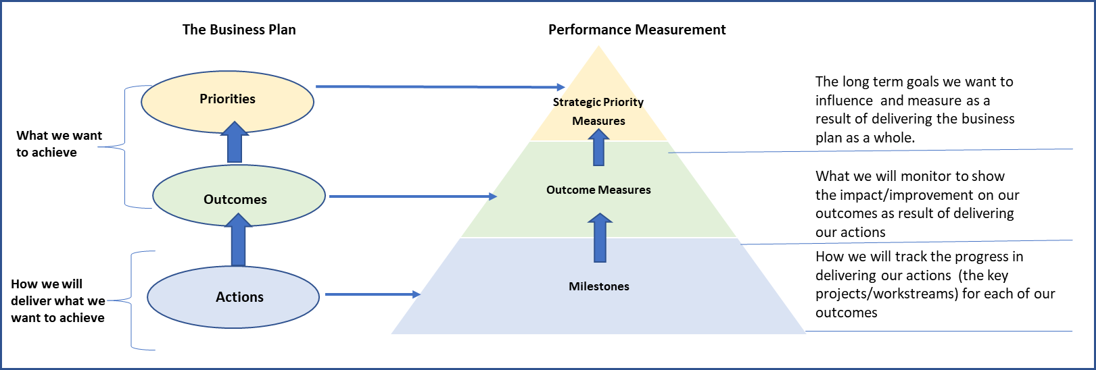

To do this we will measure and monitor:

Actions (short term – 2 years): The delivery plan identifies the specific detailed actions we will undertake in the next two years to progress the outcomes in the Business Plan. To track our progress, we have assigned short term milestones targets for each of the actions.

Outcomes (medium-term 3-5 years): For each outcome we have identified the key performance indicators that we expect to impact/improve in the medium term as a result of completing the actions in the delivery plan. Where possible, an aim and an annual target will be set for each outcome measure:

Aims: this is the estimated impact we are aiming to achieve in the medium term as a result of completing our actions. The aims are based on the current position and what we know now, for example: current demand, performance, financial position.) and following the successful delivery of the actions.

The Plan, which covers a five-year period, includes a number of assumptions such as budget and business case approval, that will be required to progress some of the actions. Therefore, aims will be reviewed on an annual basis and refined as the actions and projects develop and in response to changing internal and external factors in subsequent years.

Annual targets: we will also set an annual target for each measure to track progress towards our aims. The annual target will reflect what we aim to achieve whilst we progress the improvement actions in the Plan.
Overarching Strategic Priority measures (long term 5-10+ years): these are the long-term overarching measures we expect to influence over time by delivering the Business Plan priorities and outcomes as a whole. We have identified a set of 12 measures which are primarily city-wide measures. City-wide measures reflect areas where we may be able to influence changes in performance but are not in sole control of all the factors that may impact performance. Whilst it is not always possible to set a specific performance target for city wide measures, they provide a useful barometer for overall progress of the Business Plan and may inform decisions to take additional/remedial actions.

Monitoring the Quarterly Public Performance Scorecard:

The Public Performance Scorecard is a suite of core services KPI’s from across the Council to monitor the day-to-day delivery of services. It will be monitored on a quarterly basis and actions taken to address areas of underperformance.

Key Performance Indicators – general principles:
Where appropriate, the performance measures that we use will be SMART: Specific, Measurable, Achievable, Relevant and Timely. SMART principles will be applied to both metric and non-metric measures such as project milestones.
Performance measures and targets will be reviewed on an annual basis to ensure that they remain aligned to the delivery plan and relevant to the key priorities, outcomes. The performance framework will evolve as the delivery plan and underpinning strategies, plans and projects currently at an early stage develop and performance measures emerge or are refined. Any changes to the measures and targets will be submitted to Committee for approval.
The suite of Key Performance Indicators (KPIs) contains a blend of measures that reflect short and long-term outcomes, outputs both qualitative and quantitative and project milestones and can be either statistical or non-statistical measures.
Setting targets against our KPIs allows us to track progress against our priorities, outcomes, service improvement actions and service delivery.
When setting targets, we use comparable past and present performance data and trends, relevant policy and/or comparison to other services, other councils, national trend and benchmarking against other cities, for example LGBF.
In some cases, a target can only be set when a baseline for the data has been established. A new baseline may be required, for example, where the KPI’s is a new measure and so no previous trend data is available, the calculation for the metric has changed from the previous year or an event has happened such that the previous year’s data is not comparable.
Appendix C – Business Plan Measures

Benchmarking

Benchmarking allows us to compare our performance to others and as a result identify opportunities to improve. Benchmarking can be undertaken externally with other councils, organisations or sectors and internally across services. Benchmarking is not restricted to comparing performance indicators alone but can be used more widely to compare approaches to similar issues and share best practice.
Over the last ten years the 32 Councils in Scotland have been working with the Improvement Service and SOLACE to develop and utilize a common approach to benchmarking – Local Government Benchmarking Framework (LGBF). This framework allows us to compare performance across a range of themes with other Local Authorities. It acts as a catalyst for improving services, targeting resources to areas of greatest impact and enhancing public accountability.
The Improvement Service prepare an annual report on the LGBF themes and Indicators and provides access to their online tools to drill through the data. The latest report and tools can be accessed on their website.
We carry out additional analysis on the data which includes a five-year trend analysis and comparison to the national average, the LGBF family group and urban comparators. The report is discussed by the Corporate Leadership Team, Executive Directors, Service Directors/Heads of Service and senior managers across the Council to highlight areas of under-performance or best practice and inform future service planning and improvement actions. The report is then submitted to Committee on an annual basis for further scrutiny and published on our website for citizens to access.
As part of the new Planning and Performance Framework, we will use LGBF data alongside the Council’s own performance data as part of the annual review process (detailed on page 7 of this report - Continuous Improvement Cycle). Our performance and benchmarking data will be used to review performance against our plans and inform the next year’s annual planning process.
Across the Council there are several other sources for benchmarking, many of which are sector/service specific such as Insight-Virtual Comparator (Education and Children’s Services), Keep Scotland Beautiful, House Mark and the Association of Public Sector Excellence networks (APSE).

Performance monitoring and scrutiny

For the Business Plan we will develop scorecards to track and monitor the key actions, milestones and the associated KPI’s.
We also develop a quarterly Public Performance Scorecards and trend dashboard to provide a general view of performance across core services.
Performance monitoring is further enhanced through detailed service management information and operational data embedded across the organization.

Council Management Teams
The Corporate Leadership Team (CLT) will monitor performance on a regular basis. Executive Directors and Service Directors will present their performance information and if required provide service improvement actions that have been identified as part of their monthly performance monitoring meetings. As part of the reporting cycle CLT will also review and approve our performance reporting prior to submission to Council Committees.
Line Managers are responsible for our performance conversations framework, ensuring colleagues have clear objectives linked to service plans and regular review meetings.
Managers also receive a wide range of service specific management and operational information reports on a daily, weekly and monthly basis.

Elected Members Scrutiny

Elected Members scrutiny of strategies, plans and performance is aligned to the Committee structures and relevant to the role and remit of each Committee. Each Committee receives a range of performance related information through progress reports on strategies and plans as well as routine and ad hoc service delivery performance reports as agreed. Where appropriate reports are referred to Full Council for consideration.
On an annual basis we will submit a Business Plan Progress Report to the Policy and Sustainability Committee. The report will provide an update on the Business Plan actions and milestones, performance against the outcome KPI’s and a health check overview of the high-level overarching measures for the Plan.
The Public Performance Scorecard will be produced on a quarterly basis and will be submitted to the Governance, Risk and Best Value Committee as part of their general remit for scrutiny across the Council. Any significant concerns with a particular area of performance can be referred to the relevant Committee.
The Public Performance Scorecard will culminate in the Annual Public Performance Report at the end of the financial year. The report will be submitted to Governance Risk and Best Value Committee along with the Annual Local Government Benchmarking Update report. The Annual Public Performance Report will be referred to Full Council for consideration.

Public Reporting of Performance Information
We are also working to improve the performance reporting available to the Public via our website.
All reports submitted to Council Committees will be published on the Council’s website including:
- The Annual Business Plan Progress Report
- The Quarterly Public Performance Scorecard
- The Annual Public Performance Report
- The Local Government Benchmarking Framework Report
We will ensure that our Best Value and external annual Audit reports are available via our web pages.
The web page will also include a data section where we will publish, for example, Edinburgh By Numbers, Scottish Index of Multiple Depravation (SIMD) analysis, and Locality Profiles.

