Participation Request Form

1 Details of Community Participation Body

Name of Community Body:
Contact Name:
Contact address:
Contact Telephone number:
Contact Email:
Website (if available):

Please ensure that you include a copy of your written constitution or governance documentation if available.

2 Name of the public service authority to which the request is being made:
(Note 1)

3 Name of any other public service authority which the community participation body requests should participate in the outcome improvement process:
(Note 2)

4 The outcome that community participation body want to improve:
(Note 3)

5 The reasons why the community participation body should participate in an outcome improvement process:
(Note 4)

6 Knowledge, expertise and experience the community participation body has in relation to the outcome:
(Note 5)

7 How the outcome will be improved because of the involvement of the community participation body:
(Note 6)

8 What type of community participation body are you?
a) A community controlled body
b) A community council
c) A body designated by the Scottish Ministers as a community participation body
d) A group without a written constitution
(Note 7)

9 Additional Information

Please return all completed forms to participation.requests@edinburgh.gov.uk
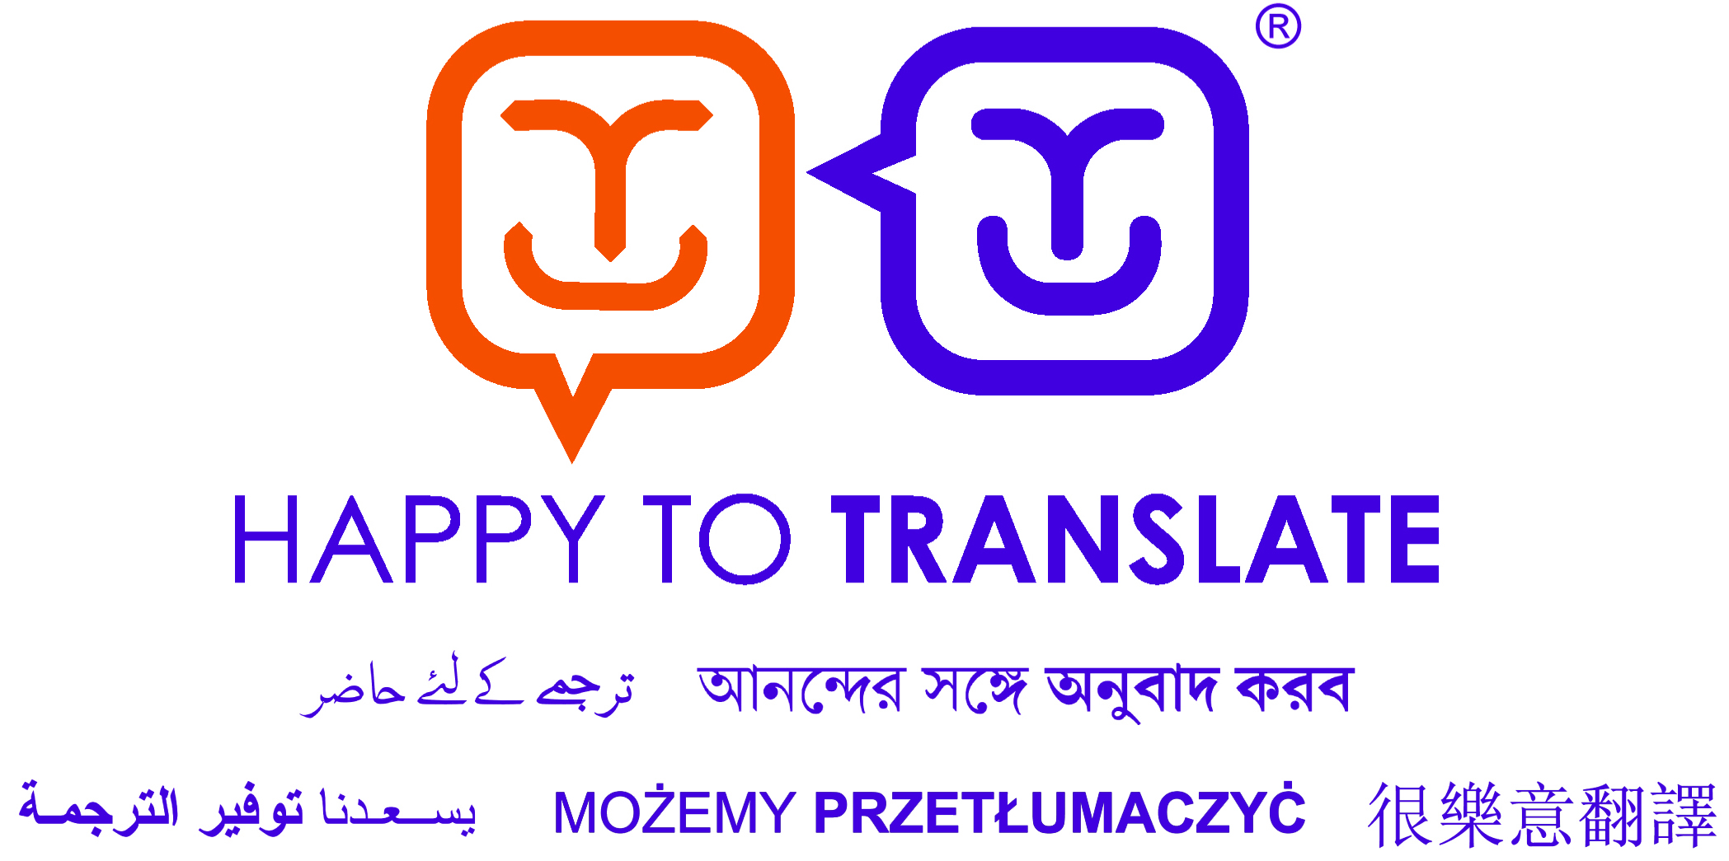
You can get this document on tape, in Braille, large print and various computer formats if you ask us. Please contact Interpretation and Translation Service (ITS) on 0131 242 8181 and quote reference number 17-1485. ITS can also give information on community language translations.
Data Protection
The information you provide in this form will be processed in accordance with your rights under data protection legislation. It will be used to progress your participation request and will not be used for any other reason without seeking your view firs (unless we are required to do so by law e.g. to prevent or detect crime).
When received, your participation request will be assessed by the Strategy and Insight Division in the City of Edinburgh Council. We will decide how best to direct your request. It will be forwarded to the relevant Council department and also, any other public service(s) that needs to be involved. Other public services who may be involved in participation requests could include:
- another local authority
- a Health Board
- the board of management of a college of further education
- Highlands and Island Enterprise
- a National Park Authority
- Police Scotland
- Scottish Enterprise
- The Scottish Environment Protection Agency
- Scottish Fire and Rescue Service
- Scottish Natural Heritage
- a Regional Transport Partnership
We will let you know how your request is being progressed, who it has been shared with, and why.
All participation requests are logged and stored upon a Council run database. The database is provided by a company called AXLR8, and data is stored upon servers based within the UK. Records of all requests will be retained by the Council for 5 years after which they will be reviewed. Records will be automatically deleted after 5 years if your participation request is refused. If you have any questions on how the City of Edinburgh Council uses your information please refer to our Privacy Policy.

